Assignment 4: WK4 Midterm Project
Sean F. Coggeshall
American Military University

Table of Contents
Assignment 4: WK4 Midterm Project 3
Three Types of Computers 3
Software and Hardware Integration 3
Application Software’s. 4
Operating System 5
References 6
Figures 7

Assignment 4: WK4 Midterm Project

Three Types of Computers
The first type of computer that comes to mind for me is the personal computer. A personal computer is a computer that is designed to be used by one person at a time. Typically when someone refers to a personal computer they will just say “PC” for short. These are most often desktop computers used for gaming, school, or normal web browsing. A personal computer processes information with a CPU, installed RAM, and input/output units.

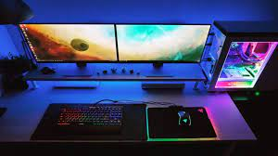
Another type of computer would be a Mainframe Computer. A mainframe computer is used for bulk data processing. This can refer to things such as consumer statistics and large organization/enterprise transaction processing.
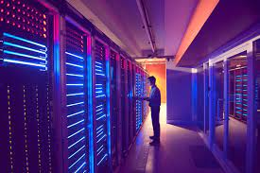
And lastly, a third type of computer is the supercomputer. A super computer is a computer that perform at a high level compared to personal computers. They are used to calculate large mathametical equations that help with weather forecasting, scientific simulations, nuclear research. Below is an image of a supercomputer “DeepBlue”, designed to play chess at an extremely high level. 

Software and Hardware Integration 1
Software and hardware work together to make your computer function. They use four types of system resources. Memory resources, input/output addresses, interrupt request numbers, and direct memory access channels. For example an input hardware could be your keyboard, when typing in the keyboard the software on your computer will take that input and output the text on your monitor.
Software development is made through computer programming. A programmer can write out code through different application programming interfaces. The software goes through a test cycle and is either put back into development or pushed to be installed onto devices.
Application Software’s. Application software is a computer program that is made to do one task for end users’ efficiency.
OneNote is an application software developed by Microsoft. OneNote provides users a convenient place to take, save, and share (if wanted) notes on any given topic. It can be accessed in both the installed desktop application and has an accessible web version. You can create different tabs within a singular note to separate subcategories of a topic.

Visual Studio Code is an application software used by software developers. It has features that enable users to learn about programming using different features such as syntax highlighting, bracket matching, code folding, and configurable snippets. You can connect it to your Microsoft or Github account to access your files from any device. You can also use it to collaborate with a team.
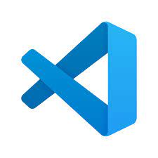
Google chrome is an application software. It is the most widely used search engine in the world. It comes with a convenient password manager that saves your passwords for sites so you can access them easily next time you visit. Chrome also comes with a panel in the top right to easily get to Gmail, Google Docs, Google Maps, Google Spreadsheets, etc.

Operating System. An operating system (OS) is a software that supports a computers function. The most common operating system on personal computers is Microsoft Windows. Windows has had several versions released, most recently is Windows 11. An OS helps with managing input and output processes, managing data storage, and the control of peripheral devices.

References
GeeksforGeeks. (2021, June 6). Types of Computers. https://www.geeksforgeeks.org/types-of-computers/
Wikipedia contributors. (2022, October 12). Operating system. Wikipedia. https://en.wikipedia.org/wiki/Operating_system

Figures
You can manipulate a Windows desktop files by going to File Explorer, clicking this PC, and then going within the local disk and opening Files as needed.



